Specification
  - MULA-LBr-0928 L&L - Expanding job ticket by sales unit of measure
Doc Version 1.0

Customer: | MULAG Fahrzeugwerk Heinz Wössner GmbH & Co. KG
Project: | MULAG relaunch
Proalpha version: | 9.4.0
Proalpha Installation(s): | DE
GUI language: | German
Author: | Lara Braun
Created on: | 23.01.2025
Last change on: | 05.02.2025
Contact person customer: | Mr. Huber

This document describes a customization or expansion of the standard software Proalpha and has been checked by the customer. The technical design in Chapters 2 - 4 is hereby released in compliance with the requirements of the "Final Provisions" section of the technical specification and costing:

............................................
Date and signature customer

Contents
1. [UPDATE THE TABLE] 3
1.1 [UPDATE THE TABLE] 3
1.2 [UPDATE THE TABLE] 3
1.3 [UPDATE THE TABLE] 3
1.4 [UPDATE THE TABLE] 4
2. [UPDATE THE TABLE] 4
2.1 [UPDATE THE TABLE] 4
2.2 [UPDATE THE TABLE] 4
2.2.1 [UPDATE THE TABLE] 5
2.3 [UPDATE THE TABLE] 5
3. [UPDATE THE TABLE] 6
3.1 [UPDATE THE TABLE] 6
4. [UPDATE THE TABLE] 7
4.1 [UPDATE THE TABLE] 7
4.2 [UPDATE THE TABLE] 7
4.3 [UPDATE THE TABLE] 7
5. [UPDATE THE TABLE] 8
5.1 [UPDATE THE TABLE] 8
5.1.1 [UPDATE THE TABLE] 8
5.1.2 [UPDATE THE TABLE] 8
5.1.3 [UPDATE THE TABLE] 8
6. [UPDATE THE TABLE] 9
7. [UPDATE THE TABLE] 10
7.1 [UPDATE THE TABLE] 10
7.2 [UPDATE THE TABLE] 10
8. [UPDATE THE TABLE] 11

Requirements

References
Voting between Mr. Huber and Mrs. Braun via Teams on 17.01.2025 and Case CS0348037

Summary and objective
Information from the sales unit of measure of the part is to be printed on the List & Label form job ticket.

Request Description
MULAG wants to output the packaging instruction and the fill quantity of the main sales unit of measure on the job ticket:
The packaging instruction is defined in the part of the work order.
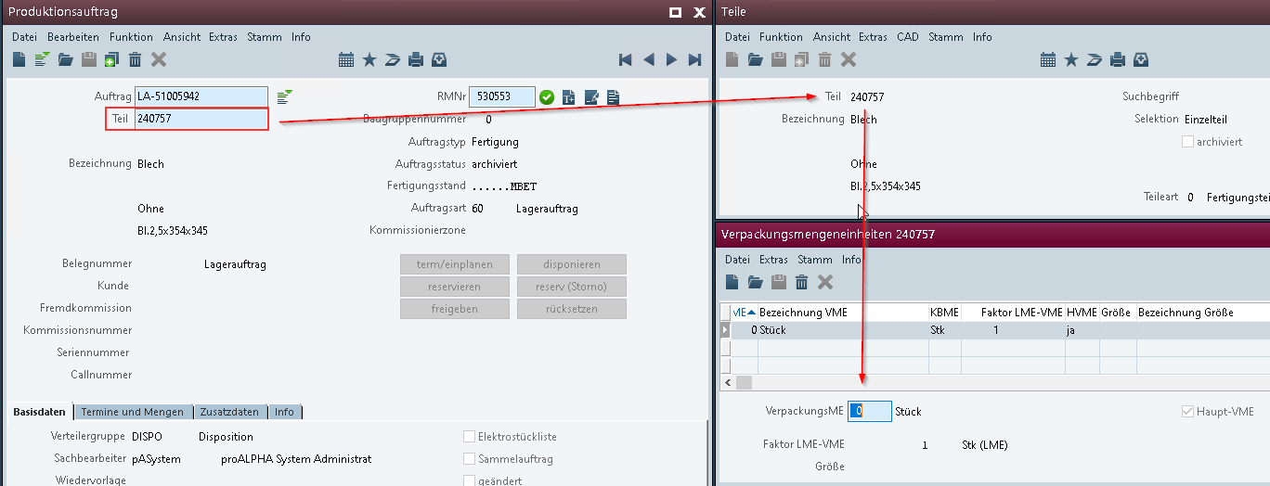
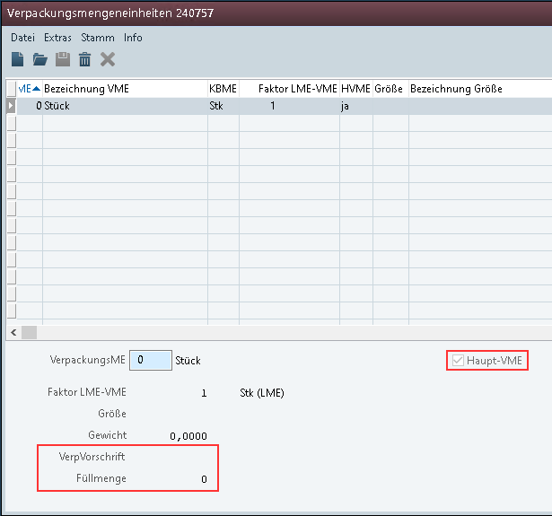

Request Glossary (Term Statement)

Term | Explanation
PP0 | job ticket
Table 1: request glossary

Professional design

Solution summary
Extension of the job ticket data base by the sales unit of measure.

Solution description
The S_ArtME (sales unit of measure) table is added to the data base PP0 in relation 1:1 below the part work order:
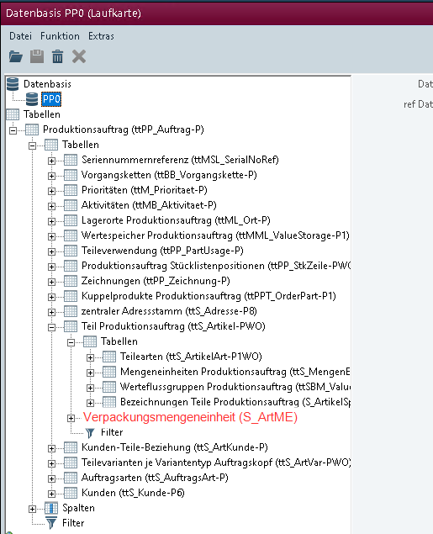
Only the main SaUM is to be output, hence the relation 1:1.
Note: The final design of the form layout is adopted by the customer and is not part of the implementation of this specification.

<Template for Section>

Business logic & GUI

Data model

Output

Accruals and deferrals
The adjustment refers to the tables, fields and programs mentioned.
These specifications do not automatically add functional enhancements to adjacent modules of the Proalpha environment, such as DMS, Analyzer, reports, and forms. The Proalpha Help is not automatically expanded.
Changes to adjoining modules/programs have to be described and defined in the functional specifications. It also includes changes to the GUI. If Ray is not specifically mentioned here, this customization refers to the Classic Proalpha client.

Test cases
The specified test cases map the adjustment described here and are the basis for the acceptance of the software.

Completing the fields in the form and printing
Pt | Explanation | Expected result | Test data
 | Open L&L Designer for job ticket | L&L Designer opens and the table described under 2.2 is available
 | Completing the fields from sales unit of measure in the layout
 | Print Job Ticket | The fill quantity and packaging instruction are filled with the corresponding | WO with part for which a main sales unit with fill quantity and instruction has been defined
 | Test result (incl. screenshots)

Prerequisites

Technical requirements
The use of Proalpha functionalities outside the Concurrent User Model (connection of external systems, background processing) requires the licensing of so-called software services.
"Using Proalpha functionalities" refers to any use or access to the Proalpha infrastructure, e.g.
- Writing to Proalpha data structures
- Calling Proalpha classes and other business logic
- Opening Proalpha Services
The following software services are therefore required for the implementation described in the functional specification:

Organizational requirements

Notes about the commissioning

Technical design

Final provisions
These specifications form the basis for customer-specific expansions of the standard software Proalpha®.
The customer-specific extensions only cover the category defined in this specification. Functionality beyond this scope is not provided.
Unless expressly agreed otherwise, the customer-specific extensions are only created in German: no programs, program parts or data are translated into other languages. This also applies to the languages supported by Proalpha® in the standard version.
The customer-specific expansions are carefully tested before they are delivered. However, for technical reasons, it is not possible to perform the test under the same conditions and with the same data that will be used by the customer. It is therefore recommended to carefully check the functions after they have been delivered in the real system environment.
The Customer understands that variances in the display details or handling of the features defined in this Statement of Work may be required for the transfer of the features defined in this Statement of Work to new versions of Proalpha®. This specification also remains valid in this case, provided that there is a maintenance agreement for the customer-specific extensions defined in this specification and no changes to the functionality have to be agreed on.
This specification documents the customer-specific expansions. No other documentation beyond that contained in this SOW shall be provided. Questions about customer-specific expansions are received and forwarded by the hotline.
By signing on page 1, you confirm:
- that the specification is accepted in this version and becomes part of the contract,
- that this specification defines the functional scope of the software to be created and that there are no side agreements regarding the functionality,
- that a technical specification is created for the functional specification, which is then invoiced separately if the quote is not ordered in the context of the quote validity for the implementation of the functional specification.

Appendix

Table of Figures
No entries could be found for a table of figures.

Table of tables
[UPDATE THE TABLE] 4

Change history
Doc -  Version | Date | Contact | initiator | Chapter | Explanation
1.0 | 23.01.2025 | Lara Braun | Mr. Huber | All | Initial new entry

